KUBERNETES CONFIGMAP
A ConfigMap in Kubernetes is an object used to store configuration data in the form of key–value pairs.
It allows you to separate configuration from your application code and containers so that you can change settings without rebuilding or redeploying images.
ConfigMap is a Kubernetes resource that stores non-confidential configuration data (key-value pairs) and makes it available to Pods as environment variables or files.

Why ConfigMap is used?
- To keep configuration outside of container images
- To update application settings without rebuilding images
- To pass configuration to pods in a clean and manageable way
- To mount configuration files inside containers
- To reuse the same app image for different environments (dev, test, prod)

What ConfigMap stores?
- Key–value pairs
- Entire configuration files
- Script contents
- JSON, YAML, properties files, etc.

How Pods use ConfigMaps?
Pods can use ConfigMap data in two ways:
- As environment variables
- As files mounted inside the container

Create configmap
Vi configmap.yaml
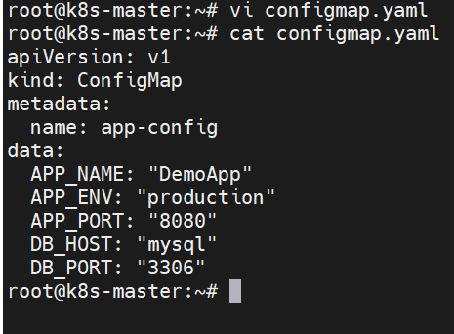
Step 2: Create a Pod that uses the ConfigMap
Vi pod-configmap-demo.yaml
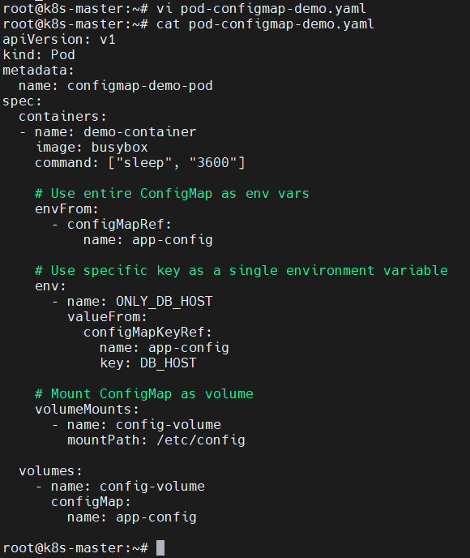

kubectl apply -f pod-configmap-demo.yaml
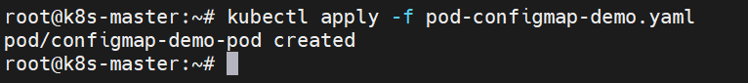

Step 3: Verify Inside the Pod
Check env vars:
echo $APP_NAME # DemoApp
echo $APP_PORT # 8080
echo $ONLY_DB_HOST # mysql

Check mounted files:
ls /etc/config
cat /etc/config/APP_ENV # production
cat /etc/config/DB_PORT # 3306
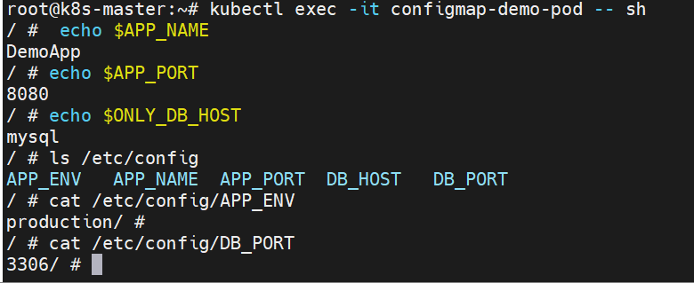

================================================

Step 1: Create a ConfigMap with a custom nginx.conf
vi nginx-configmap.yaml
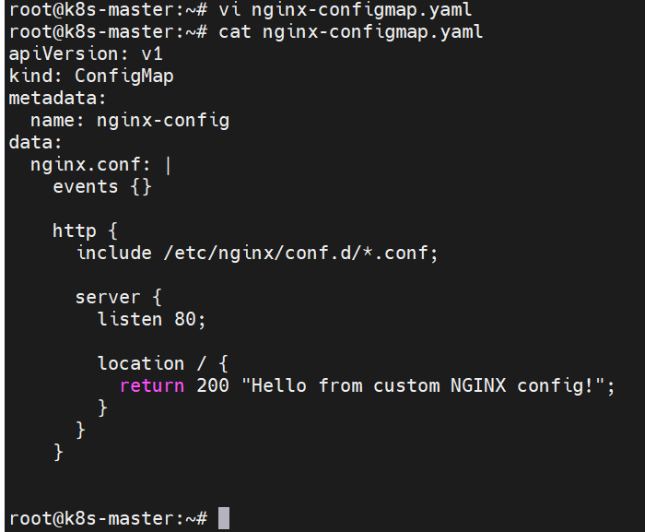
kubectl apply -f nginx-configmap.yaml
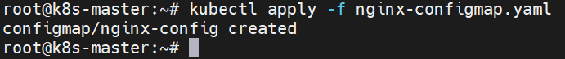
Step 2: Create a Pod using this ConfigMap
Vi nginx-pod.yaml
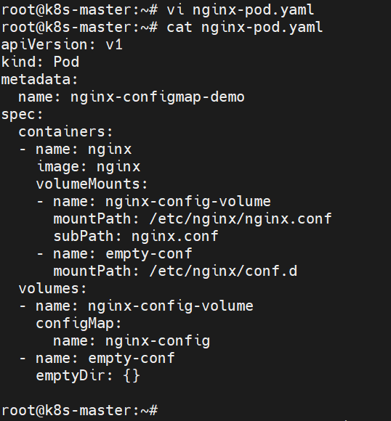

kubectl apply -f nginx-pod.yaml
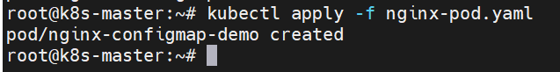
Step 3: Test It
curl http://localhost:8080
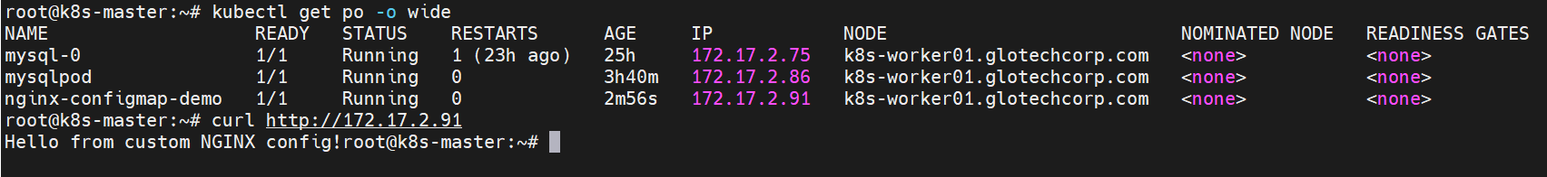
================================================

Create a Pod that uses the ConfigMap to set an environment variable.
Create yml file for ConfigMap
$ vi mycon.yml
$ kubectl create -f mycon.yml
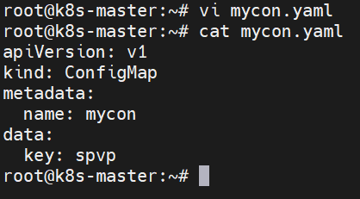
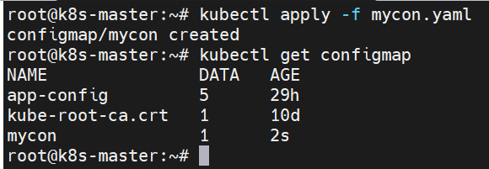

Create yml file for pod
$ vi mypod.yml
$ kubectl create -f mysqlpod.yml
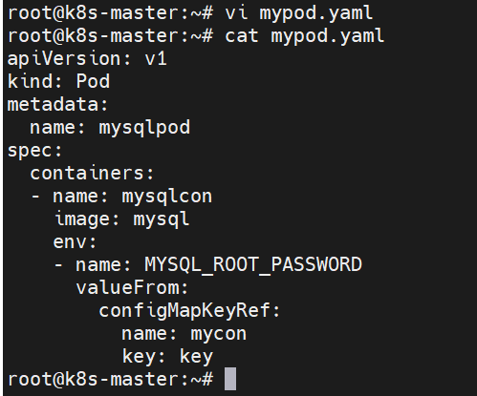

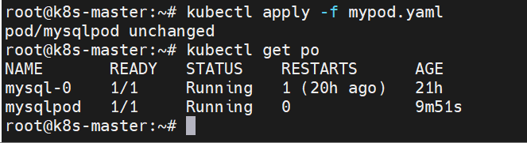

$ kubectl exec -it mysqlpod -- bash
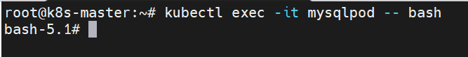

bash5.1# mysql -u root -pspvp
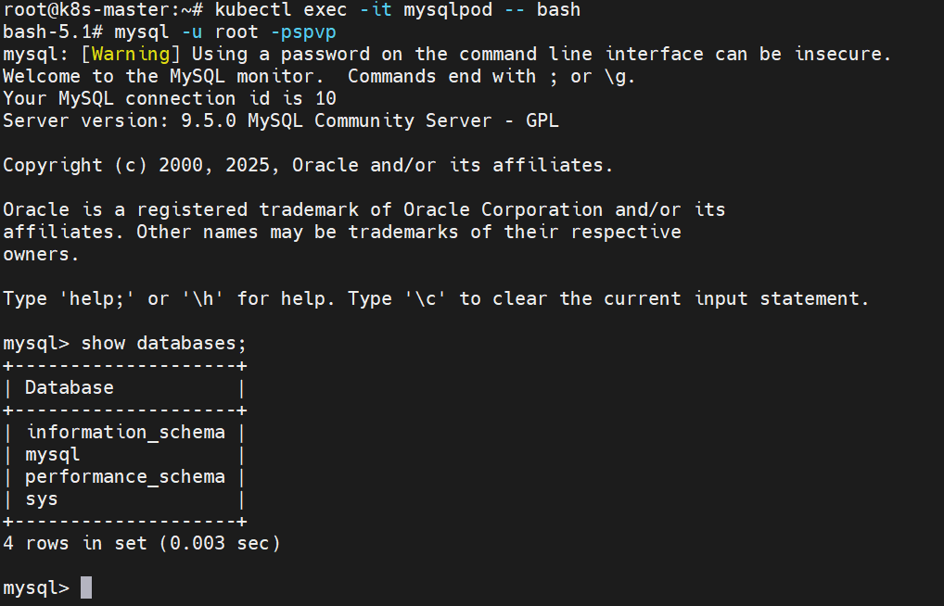

Update the ConfigMap and verify that the Pod is updated.
$ kubectl edit configmap mycon
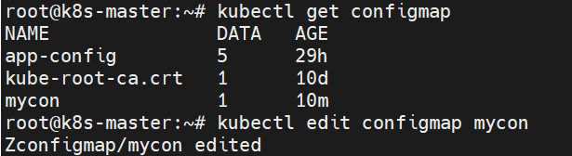

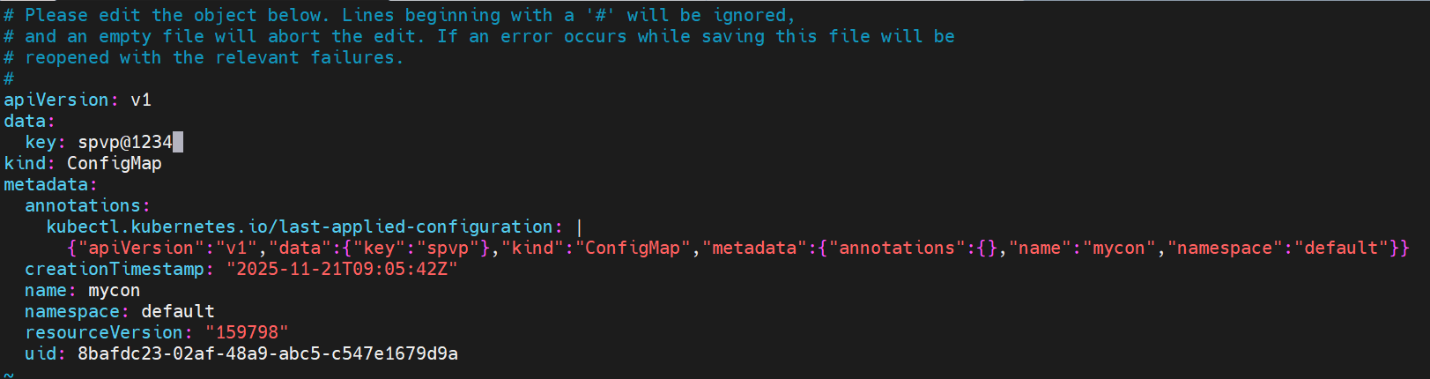

Delete the old pod and then create a new pod
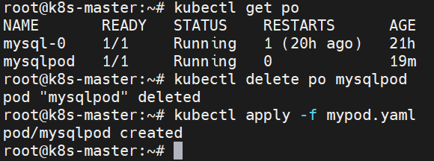

$ kubectl exec -it mysqlpod -- bash
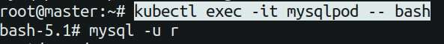
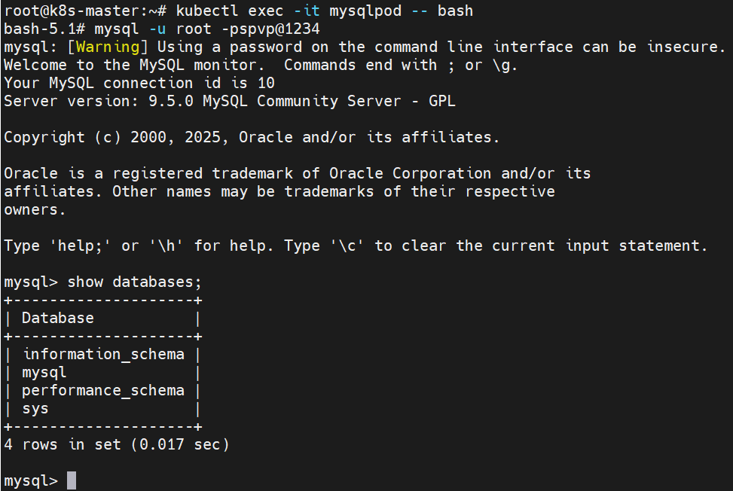

============================================================================

Lab 2
From a file: Let's say you have a configuration file named file:
$ Vi file
controlplane $ k create configmap mycon --from-file file configmap/mycon created

Now I viwe the created config map into the yml file controlplane $ k get configmaps mycon -o yaml > my.yml
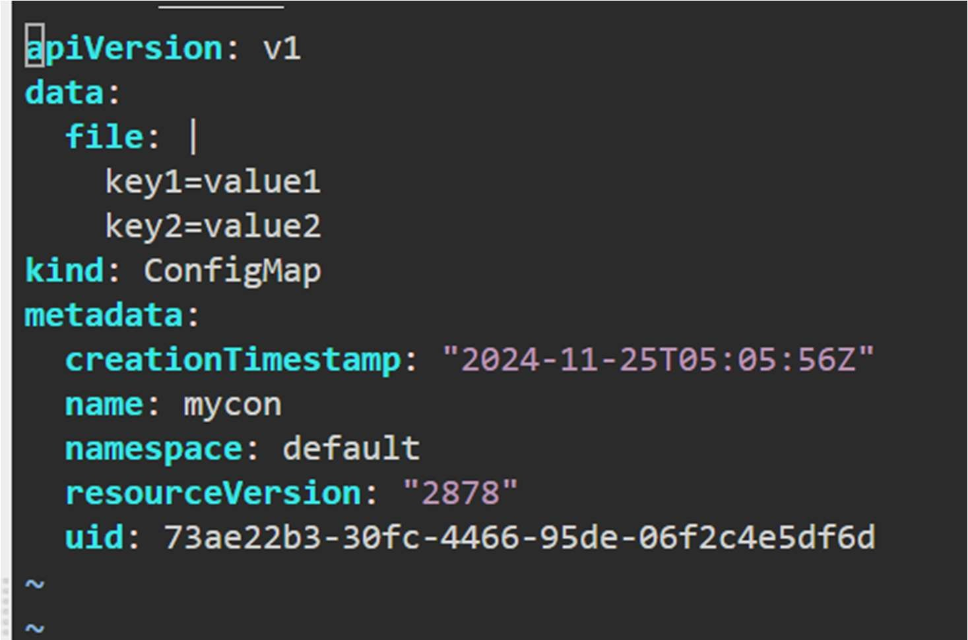

By using this command we can also create an multiple files also kubectl create configmap my-configmap --from- file=app.properties --from-file=database.properties

Now we create an config map without create an file we use directly litral value.
kubectl create configmap my-configmap --from- literal=key1=value1 --from-literal=key2=value2
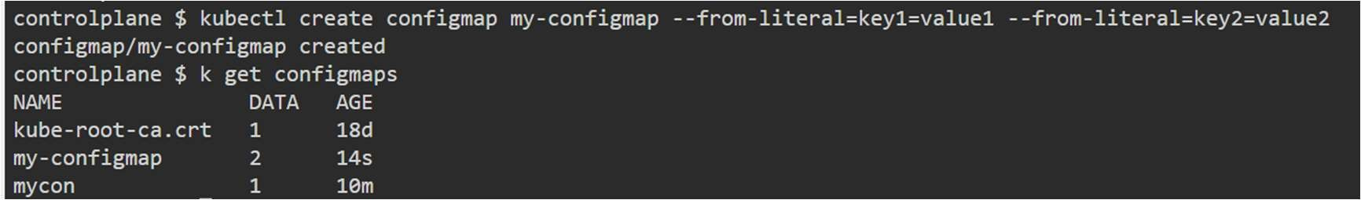
Now I viwe the config map into the yml file.
controlplane $ k get configmaps my-configmap -o yaml > myconf.yml controlplane $ vi myconf.yml

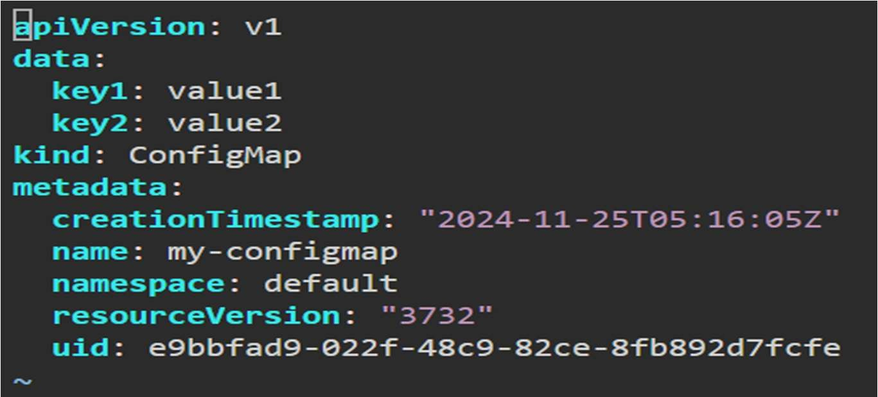

Using a combination: Combine files and literals:
kubectl create configmap my-configmap --from-file=file --from-literal=extra-key=extra-value
